Stellar Evolution
Name
Institutional Affiliation

Part 1 Stellar Evolution
After watching the video on stellar evolution you should be able to complete the following flowchart showing the lifecycle of a low mass vs. high mass star using the terms below

Main Sequence Star

Runs out of H in core

Red Giant

Low Mass (<8M_{sun}) High Mass (>8M_{sun})
Produces Produces
Core Collapse Supernova
White Dwarf

Leaving behind Leaving behind
Lower Mass Largest mass
(8-25 M_{sun}) (>25 M_{sun})
Black Dwarf
Neutron Star
Black Hole

Part 2 HR diagrams
A diagram of the Luminosity vs. Temperature was used by Hertzsprung and Russel to display information about a large number of stars in one convenient graph. We now call these figures H-R diagrams. The HR diagram on the following page shows a small sample of stars, which you can use to answer a series of questions.
The HR diagram shows that stars are products of the amount of matter around their nebula. As the star gathers mass due to the high amount of matter, it attracts hydrogen due to gravity; the situation makes it to start spinning. The high speed at which it spins makes the hydrogen to heat up such that it becomes a protostar (Dutton, 2010). Heating up increases the temperature of the star to about 15,000,000⁰ Celsius . The high temperature triggers nuclear fusion in the cloud’s core which makes it to illuminate brightly, it contracts and becomes stable as the sun and continues to shine for millions of years.
On the other hand as the hydrogen glows the nuclear fusion changes it to helium; therefore, the amount of helium increase while the amount of hydrogen decrease; consequently, not much heat is generated leading to contraction and unstable core. The outer shell which contains some hydrogen expands cools and glows red; the red glowing is the red giant phase.

Part 3 Main Sequence Stellar properties
Complete the table below. You should be able to find information about the luminosity and temperature of stellar types from the HR diagram in this lab, or a source of your choosing (e.g. previous labs, your textbook, the internet). Calculate the lifetime directly from the equation that follows.
SPECTRAL TYPE AND PHYSICAL PROPERTIES (Mass, Luminosity, Temp, Lifetime)

 | O | B | A | F | G | K | M
Mass  [M_{sun}] | 60 | 6 | 2 | 1.5 | 1 | 0.7 | 0.2
Luminosity  [L_{sun}] | 1,400,000 | 20,000 | 40 | 6 | 1 | 0.4 | 0.04
Temp  [K] | 30,000 | 10,000-30,000 | 7,500-10,000 | 6,000-7,500 | 5800 | 3,500-5,000 | 2,000
Lifetime  [yr] | 1x10⁷ | 1x10⁸ | 1x10⁹ | 5x10⁹ | 1x10¹⁰ | 5x10¹⁰ | 1x10¹¹

Higher mass stars burn through their fuel faster and lower mass stars burn through it slower. The lifetime on the main sequence can be approximated as

T =

Where M is the mass of the star in solar masses. For the Sun, M=1.0 and then T=10 billion years. Show a sample calculation in the space provided.

HR Diagram and Physical Properties of Stars
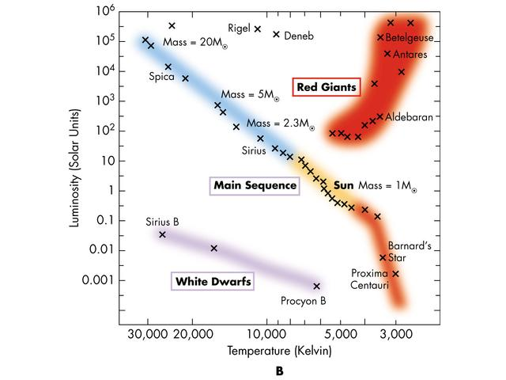
O B A F G K M
Spectral
Type Physical Properties

1 Spica Hottest main sequence stars

2 Betelgeuse Most massive main sequence stars

3 Proxima Centauri Coolest main sequence stars

4 Sun Least massive main sequence stars
5 Bernard’s star Stars most like the Sun

6 White dwarfs Types with luminosities lower than the Sun’s

7 Procyon and Proxima Centauri Stars with longest lifetimes

8 Supergiants and Bright giants Types with luminosities larger than the Sun's

9 Spica Stars with shortest lifetime

10 Proxima Centauri Types with much higher levels of ultraviolet radiation than the Sun

Bonus: Which named stars are no longer burning hydrogen in the core? White dwarfs

Part 4: Cluster ages from M-S turnoff method
Use the main sequence turnoff method from the in-class presentation to rank the following clusters from youngest to oldest. Note, the variables on the axis are different than the sample HR diagram, but they serve the same function. The visual brightness on the vertical axis stands in for luminosity, and the color on the horizontal axis stands in for temperature.

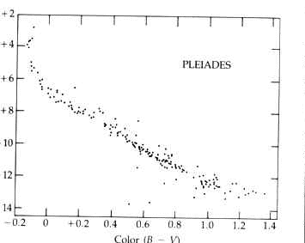
Pleiades: Open cluster

M3: Globular cluster
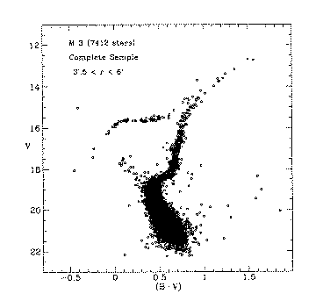

M67: Open cluster
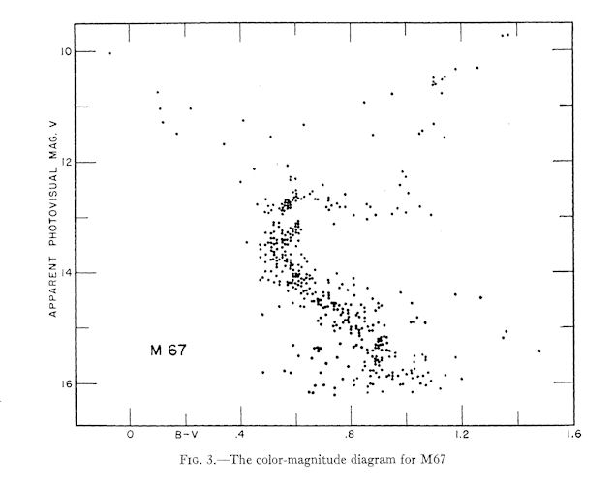

Hyades: Open cluster
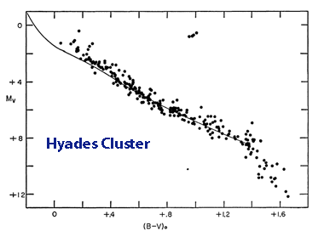

M15: Globular cluster
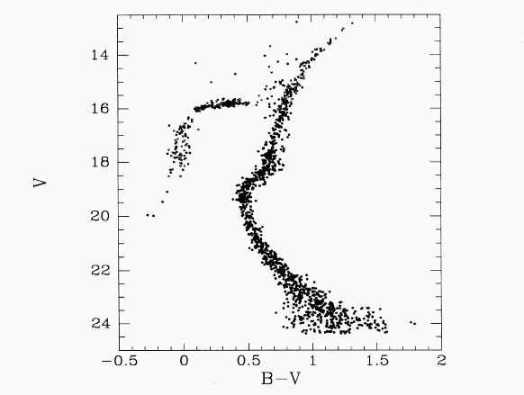

- Pleiades: Open cluster
- M3: Globular cluster
- Hyades: Open cluster
- M67: Open cluster
- M15: Globular cluster

References
Dutton, J (2010). Planets, Stars, Galaxies and the Universe. Web. Accessed on 4/11/2020

